**JAYPEE UNIVERSITY OF ENGINEERING & TECHNOLOGY** Accredited with Grade-A+ by NAAC & Approved U/S 2(f) of the UGC Act,1956 A.B. Road, Raghogarh, District Guna (MP), India, Pin-473226 

Phone: 07544 267051, 267310-14, Fax: 07544 267011

Website: www.juet.ac.in

**Weekly Progress Report**

**Week No. __3__**

Name: Sapeksh Pareek Enrolment No. 211B274 . Period: 03/06/2024 to 09/06/2024 . Work done during Week (in detail)

This week, I was tasked with creating a scraper tool for data collection using Selenium. I developed the scraper to efficiently gather required data, then created an API by setting up a Flask server. To make the API accessible over the internet, I hosted it on Vercel. This project involved integrating various technologies, such as Python for the scraper, Flask for the API, and Vercel for deployment, enhancing my skills in web scraping, API development, and cloud hosting. The successful implementation and deployment of the tool demonstrate my ability to handle complex tasks using a combination of technologies._______________________________

Section/Department of Organization (Under which training is going on)

Upgrade the existing scraper tool to extract detailed data from profiles on the designated social media platform, enhancing data extraction capabilities and optimizing API integration.___________________________________

Name of Supervisor: Ms. Anahita Zahl Tantra (HR, Yardstick)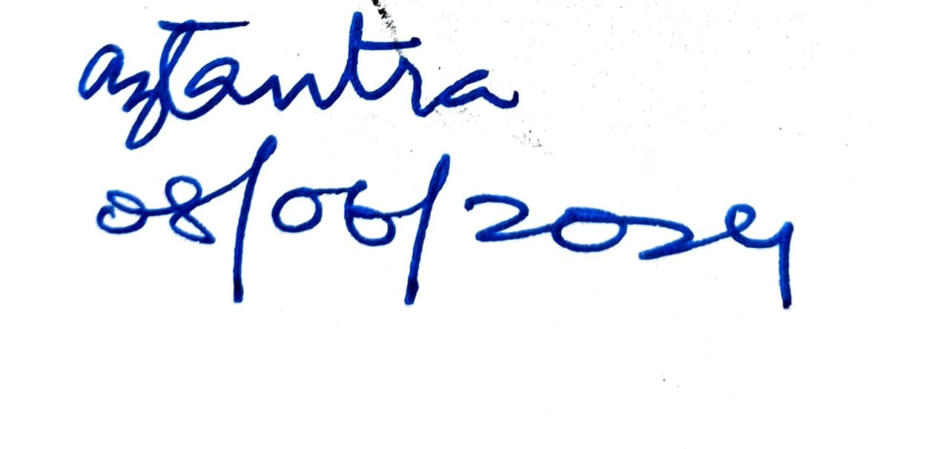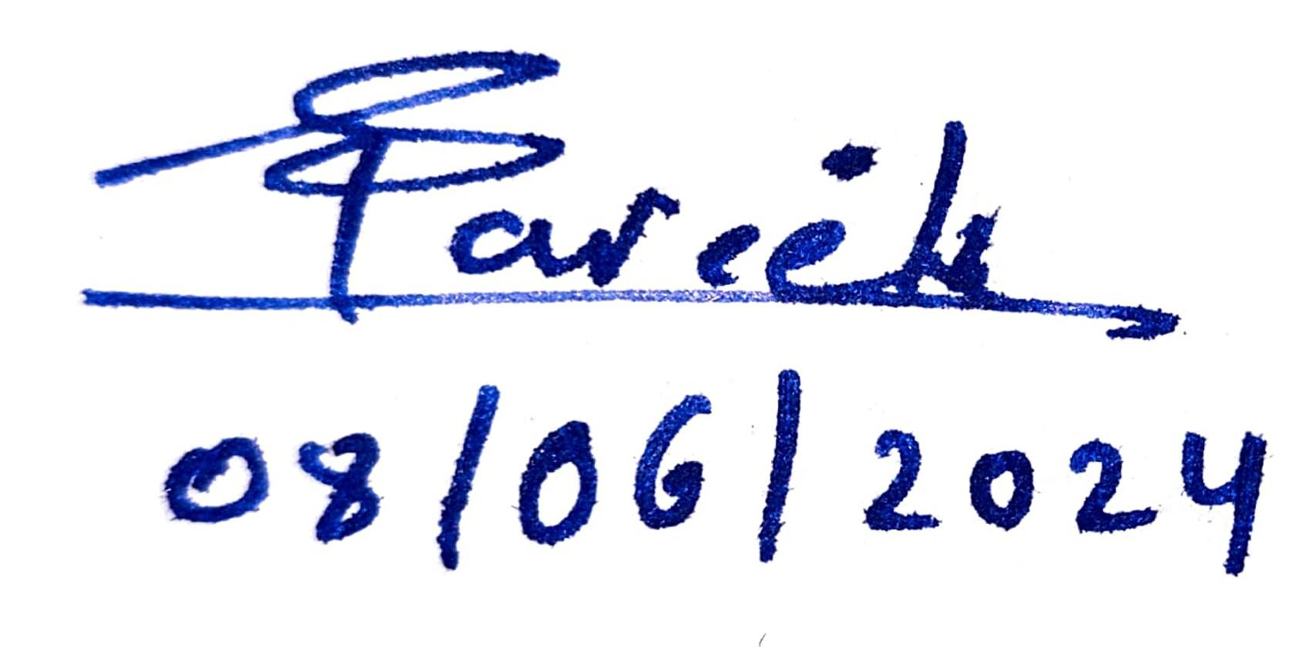

**Signature of Supervisor Signature of Student  
(with date) (with date)**